**CTF Challenge: Social Engineering**

**What is Social Engineering?**

**`**

"Social engineering" is a manipulation technique that exploits human error to gain private information, access, or valuables. It's often used by cybercriminals to trick individuals into breaking normal security procedures. Here are some key points about social engineering:

### **Common Social Engineering Techniques**

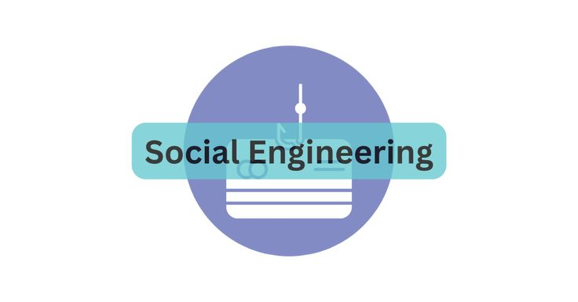

1. **Phishing**: Sending fraudulent communications that appear to come from a reputable source, usually through email.
2. **Pretexting**: Creating a fabricated scenario to obtain personal information.
3. **Baiting**: Offering something enticing to an individual to lure them into a trap.
4. **Quid Pro Quo**: Offering a service or benefit in exchange for information.
5. **Tailgating**: Following someone into a restricted area without authorization.

### **Tools for Social Engineering**

* **Email Spoofing**: Faking the sender's email address to deceive the recipient.
* **Caller ID Spoofing**: Faking the caller ID to appear as someone trusted.
* **Malicious USB Drives**: Distributing USB drives containing malware.

### **Use Cases**

* **Information Theft**: Gaining access to confidential information.
* **Identity Theft**: Stealing personal information to impersonate someone.
* **Corporate Espionage**: Stealing trade secrets from competitors.
* **Network Breach**: Gaining unauthorized access to systems or networks.

# **Capture the Flag (CTF) Challenges**

**Flag 1. Which technique involves sending fraudulent communications that appear to come from a reputable source?**

Answer: Phishing

**Flag 2. What is the term for creating a fabricated scenario to obtain personal information?**

Answer: Pretexting

**Flag 3. What social engineering method involves offering something enticing to trap an individual into a trap?**

Answer: Baiting

**Flag 4. Which tool involves faking the sender's email address to deceive the recipient?**

Answer: Spoofing

**Flag 5. What is the term for following someone into a restricted area without authorization?**

Answer: Tailgating